9/9/2024

VNPay Payment Gateway Intergration

Seamless and Secure Online Payment Solution

Han Nguyen

SparkMinds J.S.C

**Contents**

**1. Introduction** 2

**2. Overview of VNPAY** 2

2.1. Introduction to VNPAY 2

2.2. Connection Model 3

2.3. Sequence diagram 4

2.4. Supported Payment Methods 4

**3. Screen flow and work flow diagram** 5

**4. Feature** 6

4.1. Cart Page 6

4.2 Payment Page 6

4.3 Wallet Page 8

**5. Integration Process** 8

5.1. Register and Obtain API Information 8

5.2. API Structure 9

5.3. Transaction Flow 9

5.4. Error Handling 11

5.5. Integration on the BE(Java) 11

5.6. Integration on the FE(ReactJS) 17

**6. Run source** 19

6.1. Run source BE: 19

6.2. Run source FE: 19

**7. Documentation** 19

# 1. Introduction

This document is created to guide the specific steps for integrating the VNPAY payment gateway into the system. It provides an overview of the integration process, technical requirements, as well as deployment and testing instructions to ensure the system operates smoothly after integration.

# 2. Overview of VNPAY

### 2.1. Introduction to VNPAY



VNPAY is one of the leading payment gateways in Vietnam, offering a variety of convenient payment methods such as QR Code, Internet Banking, credit cards, e-wallets, etc. VNPAY helps businesses easily integrate and accept payments from users through multiple channels.

### 2.2. Connection Model

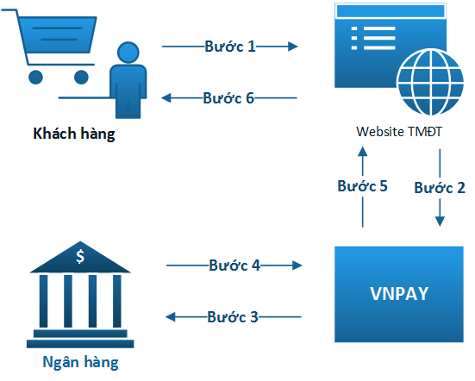

* **Step 1:** Customers make purchases on the Website - e-commerce application and make online payment for the order.
* **Step 2:** The website - e-commerce application establishes a payment request in the form of a URL containing payment information and redirects the customer to the VNPAY Payment Gateway using that URL. The  
  VNPAY Payment Gateway processes the payment request sent by the website - e-commerce application. The customer enters or processes the authentication of the requested payment information.
* **Step 3,4:** Customers enter information to verify their Bank account and authenticate the transaction (Enter account information, card or scan VNPAY-QR code).
* **Step 5:** Successful transaction at the Bank, VNPAY proceeds to:
  + Redirect customers to Website - e-commerce application ( vnp_ReturnUrl)
  + Notify the Website - e-commerce application of the customer's payment results via IPN URL. Merchant updates the VNPAY payment results sent at this URL.
* **Step 6:** Merchant displays transaction results to customer ( vnp_ReturnUrl).

### 2.3. Sequence diagram

### https://sandbox.vnpayment.vn/apis/assets/images/flow/flow-pay.png

### 2.4. Supported Payment Methods

VNPAY supports the following payment methods:

* **QR Code: Payment by scanning a QR code through a bank application or e-wallet**.
* **Internet Banking: Payment directly through the Internet Banking portal of banks.**
* **Credit/Debit Cards: Supports payment via international and domestic cards**.
* **E-Wallets: Supports payment through e-wallets such as VNPAY-QR, etc**.

**3. Screen flow and work flow diagram**

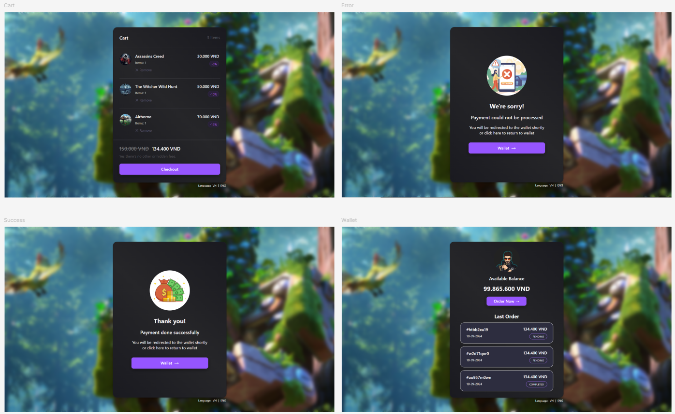

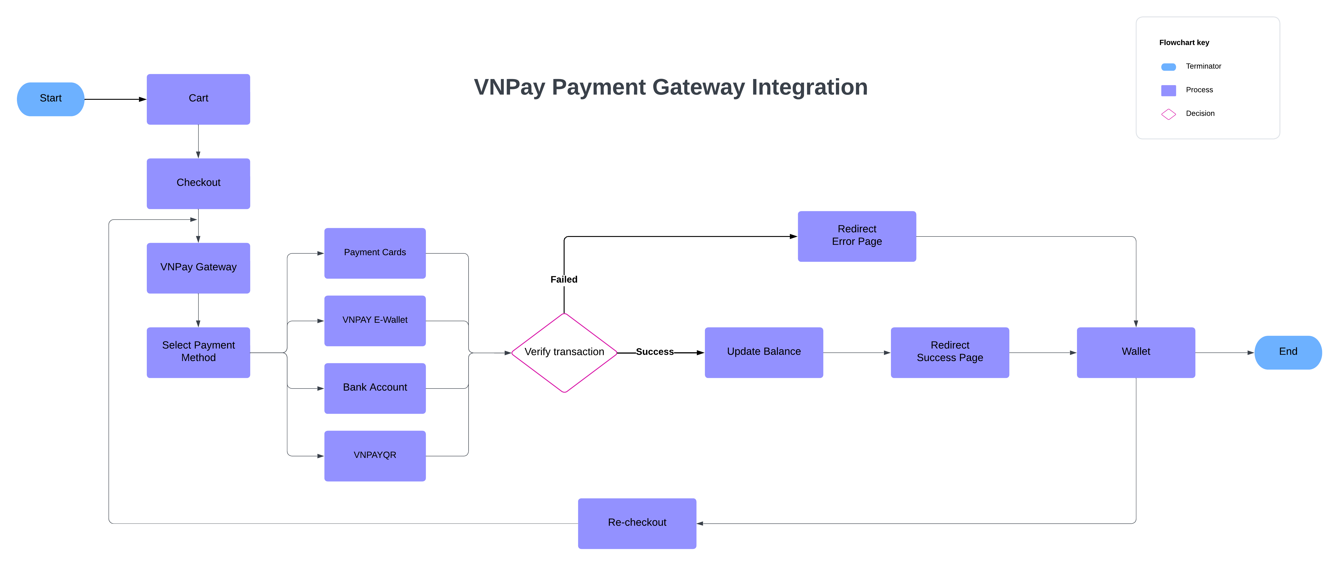

**4. Feature**

### 4.1. Cart Page

**Description:** Displays the shopping cart with static data that cannot be edited.

**Features:**

* **Static data:** Shows product information (name, price, quantity).
* **Checkout Button:** Redirects the user to the VNPay payment gateway.

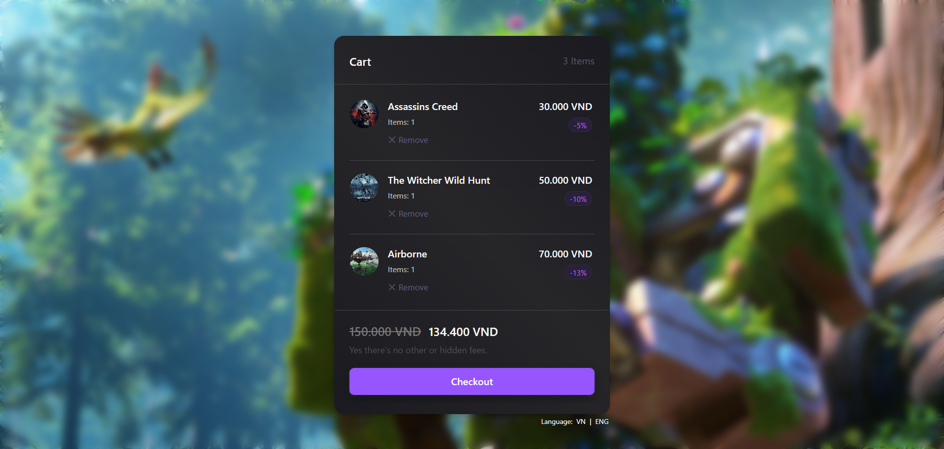

### 4.2 Payment Page

**Description:** After successful payment, based on the transaction status, the user is redirected to an error or success page, then to the wallet page.

**Features:**

* **Transaction status handling:** Redirects to an error or success page.
* **Redirect to wallet page:** After confirming the payment status.

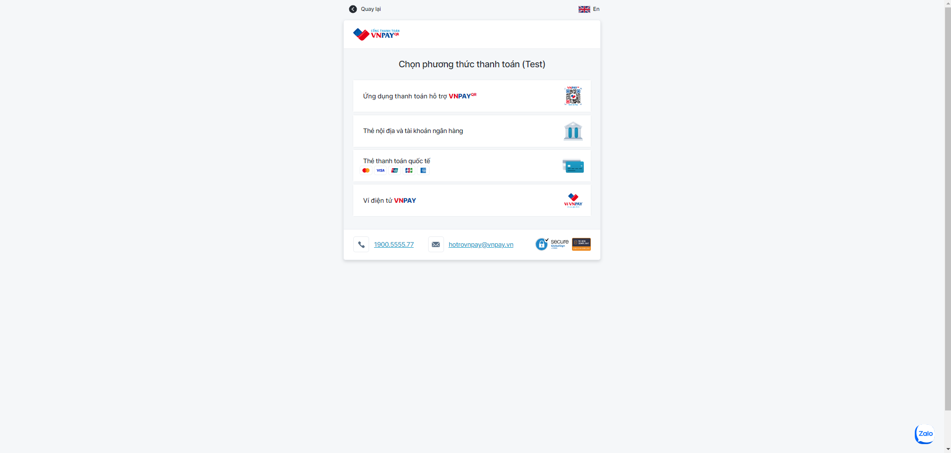

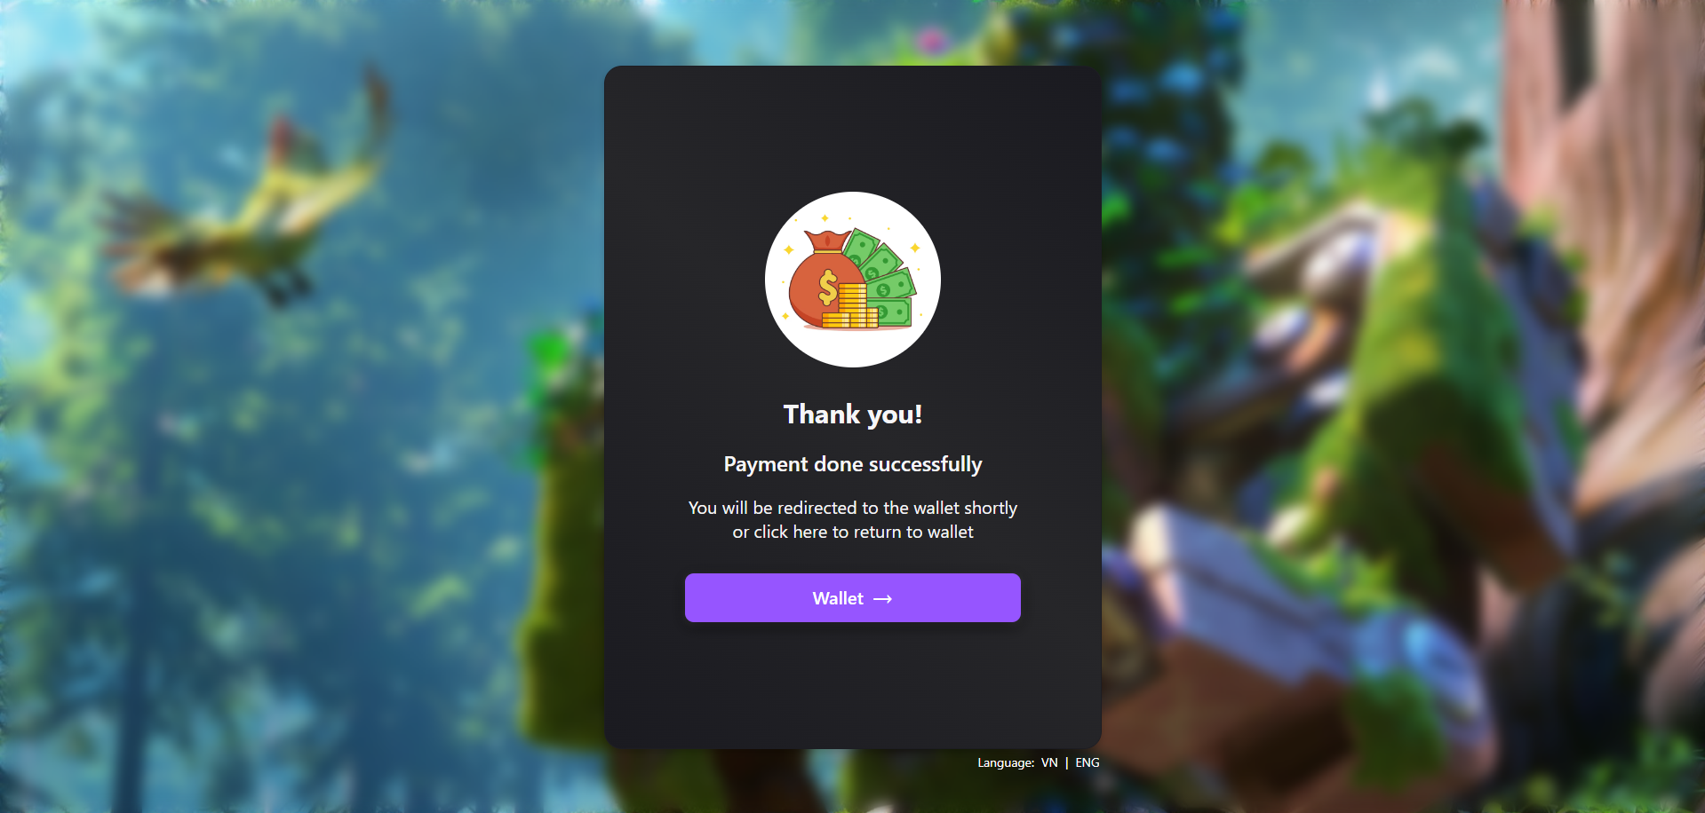

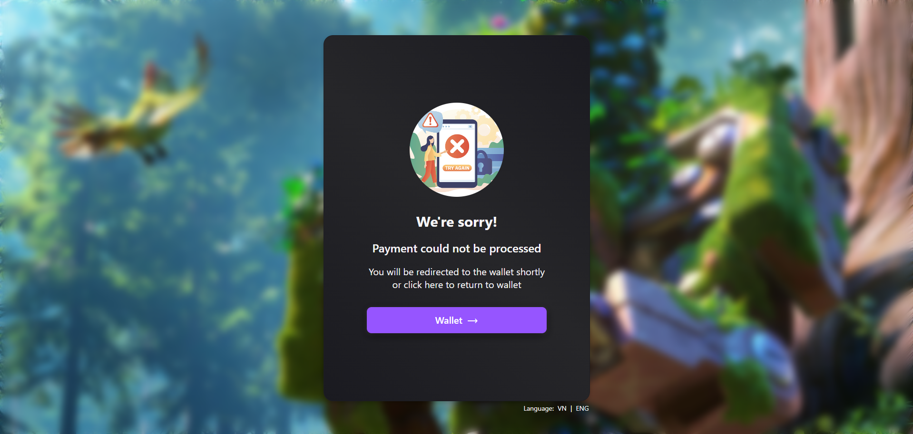

### 4.3 Wallet Page

**Description:** Displays the user's wallet, deducts money after a successful payment, and shows the top 3 most recent orders.

**Features:**

* **Deduct money:** After successful payment.
* **View recent orders:** Displays the top 3 most recent orders.
* **Retry payment:** Allows retrying payment for unpaid orders.
* **Return to cart button:** Redirects the user back to the cart page.

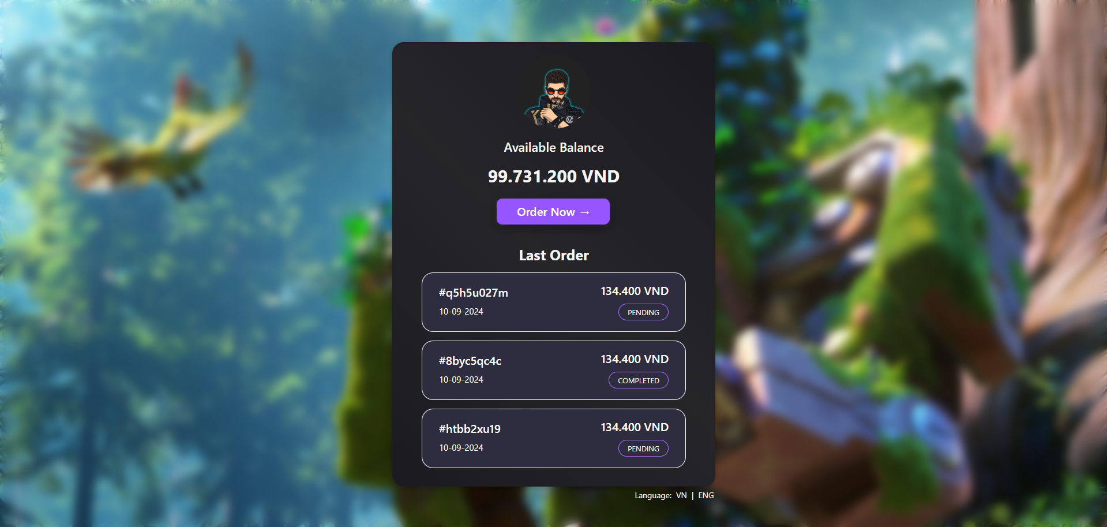

**5. Integration Process**

**5.1. Register and Obtain API Information**

* **Registration Process:** Contact VNPAY to register and obtain the necessary API information. This includes API keys, Merchant ID, and other authentication details.
* **Information to Provide:** Provide business information, website details, and technical requirements to VNPAY.
* **Link contact:** <https://sandbox.vnpayment.vn/apis/contact/>

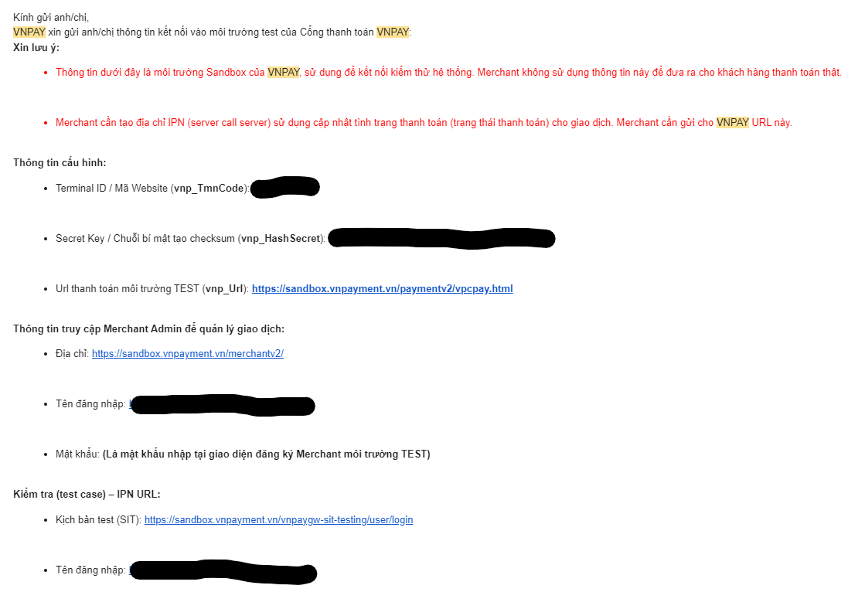

**5.2. API Structure**

* **Endpoint:** <https://sandbox.vnpayment.vn/paymentv2/vpcpay.html>
* **HTTP Method:** The primary method used is GET.
* **Data Format:** VNPAY uses JSON or XML for data transmission.

**5.3. Transaction Flow**

* **Transaction Initialization:** Your system sends a request to VNPAY to initiate a payment transaction. This request includes information such as the amount, currency, and other additional details.

**Example:**

http://sandbox.vnpayment.vn/paymentv2/vpcpay.html?**vnp_Amount**=10000000&**vnp_BankCode**=NCB&**vnp_Command**=pay&**vnp_CreateDate**=20170829103111&**vnp_CurrCode**=VND&**vnp_IpAddr**=172.16.68.68&**vnp_Locale**=vn&**vnp_Merchant**=DEMO&**vnp_OrderInfo**=Nap+tien+cho+thue+bao+0123456789.+So+tien+100%2c000&**vnp_OrderType**=topup&**vnp_ReturnUrl**=http%3a%2f%2fsandbox.vnpayment.vn%2ftryitnow%2fHome%2fVnPayReturn&**vnp_TmnCode**=2QXUI4J4&**vnp_TxnRef**=23554&**vnp_Version**=2&**vnp_SecureHashType**=SHA256&**vnp_SecureHash**=e6ce09ae6695ad034f8b6e6aadf2726f

**Parameter list:**  
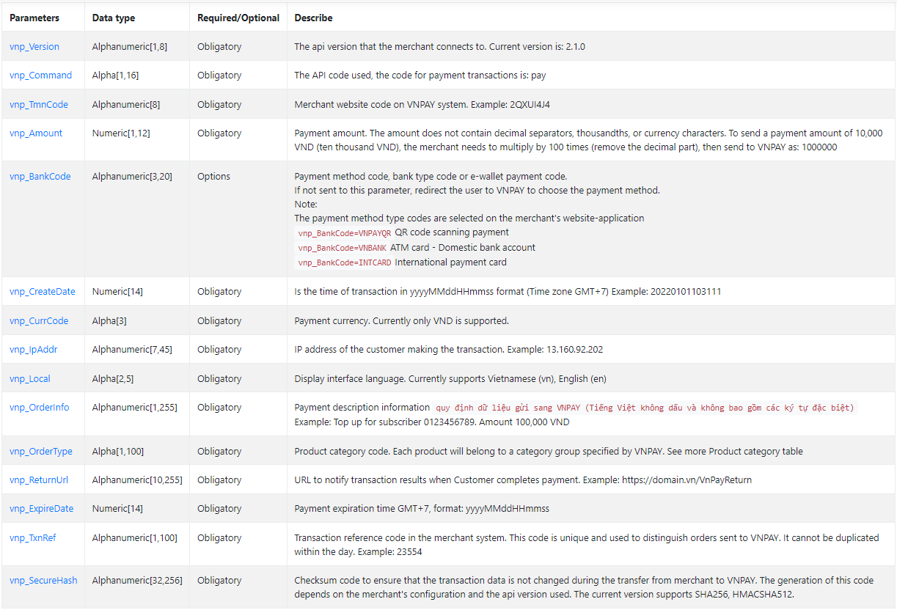

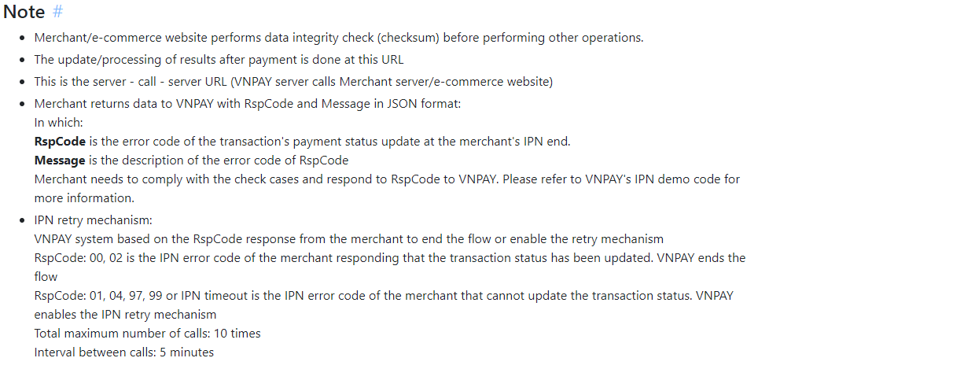

* **Redirect to Payment Page:** Users are redirected to the VNPAY payment page to complete the transaction.
* **Payment Result Handling:** After the user completes the payment, VNPAY will send the result back to your system via the callback URL.
* **Confirm and Update Transaction Status:** Your system needs to process the result from VNPAY and update the transaction status accordingly.

**5.4. Error Handling**

**Common Error Codes:** Includes error codes related to authentication, connectivity, and transaction processing.

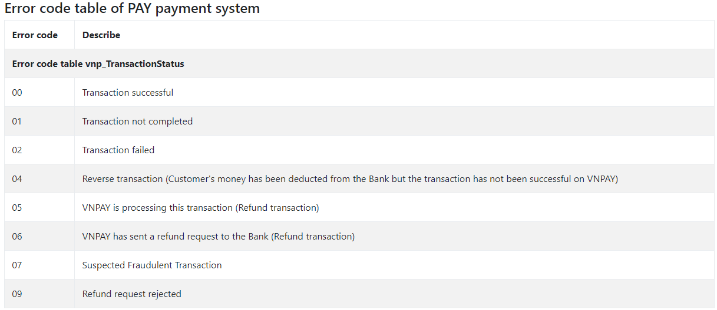

**5.5. Integration on the BE(Java)**

* **Step 1:** To be able to interact with VNPAY, we need config in application.yaml:

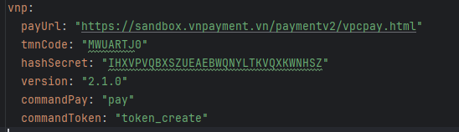

* **Step 2:** We will create an API to handle inserting the order data into the database:

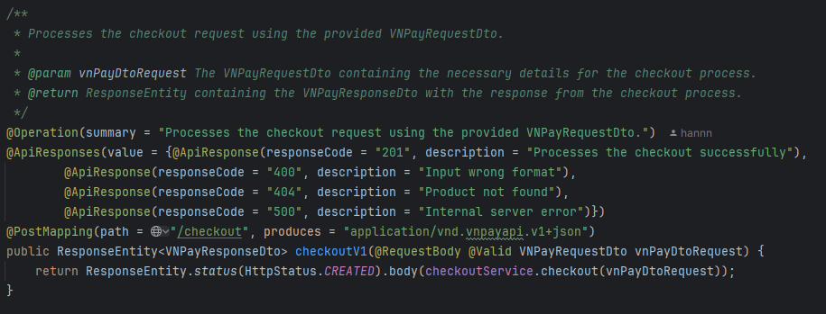

* **Step 3:** We will create the request and response for the above API:

*Request*

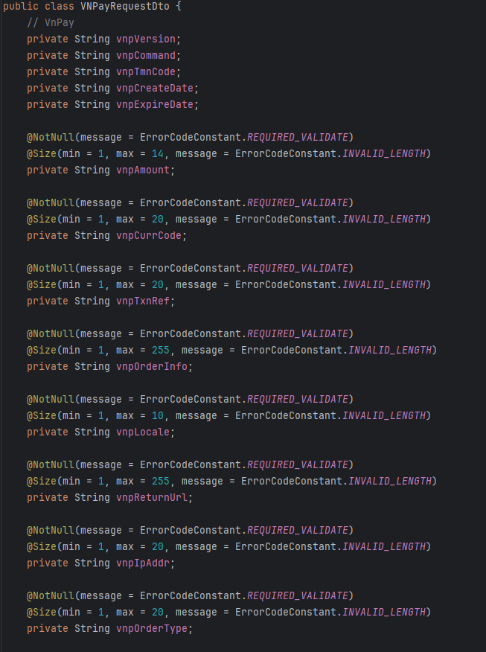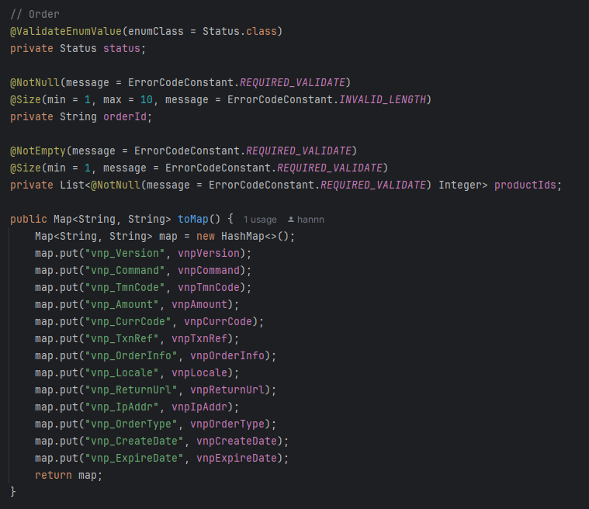

*Response*

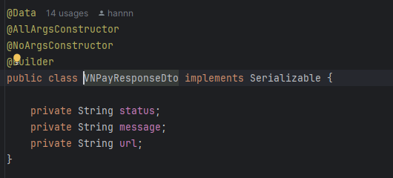

* **Step 4:** Next, we will create a service class to handle the process. Note that we need to divide the amount from the returned request by 100 to get the correct amount, and then proceed to save the order data to the database.

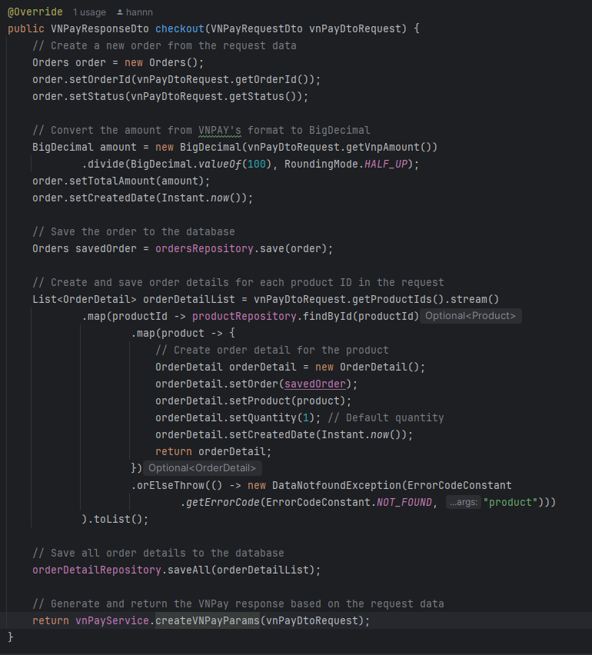

* **Step 5:** After saving the data to the database, we will create a URL to redirect to the payment gateway and return it to the client.

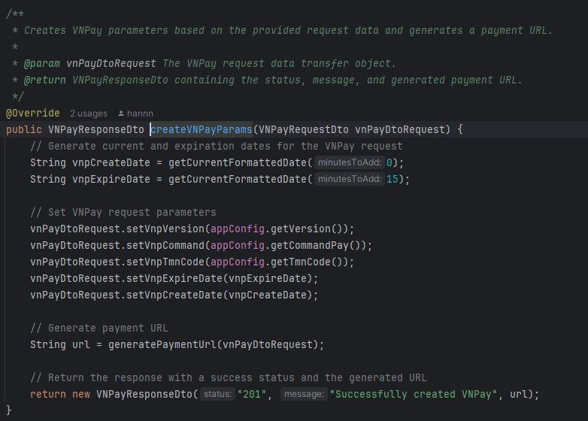

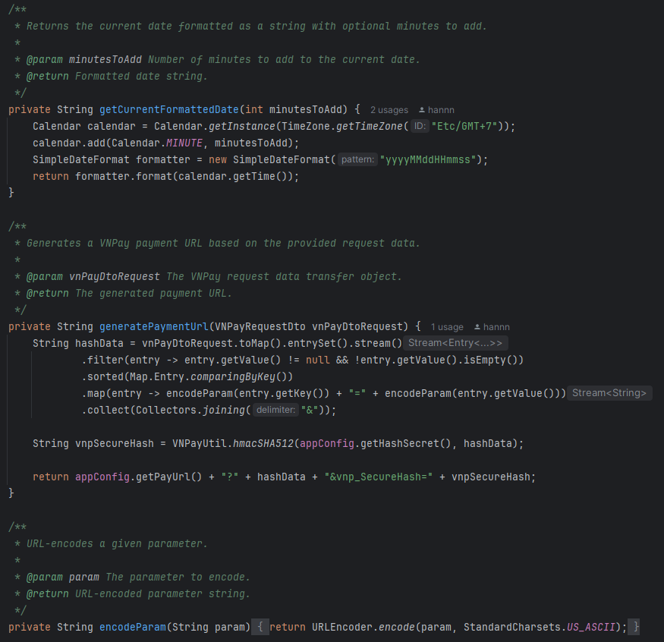

* **Step 6:** Next, we will create an API to handle the data returned from VNPAY: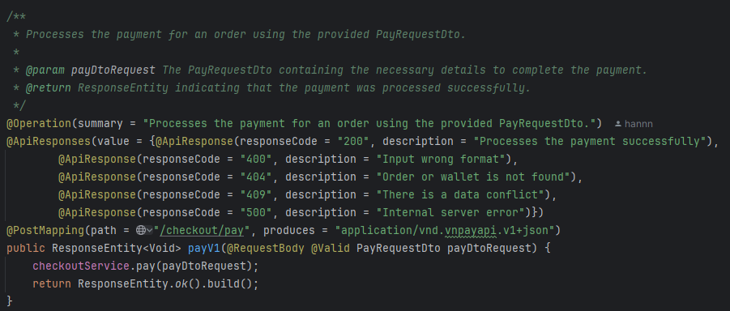

*Request*

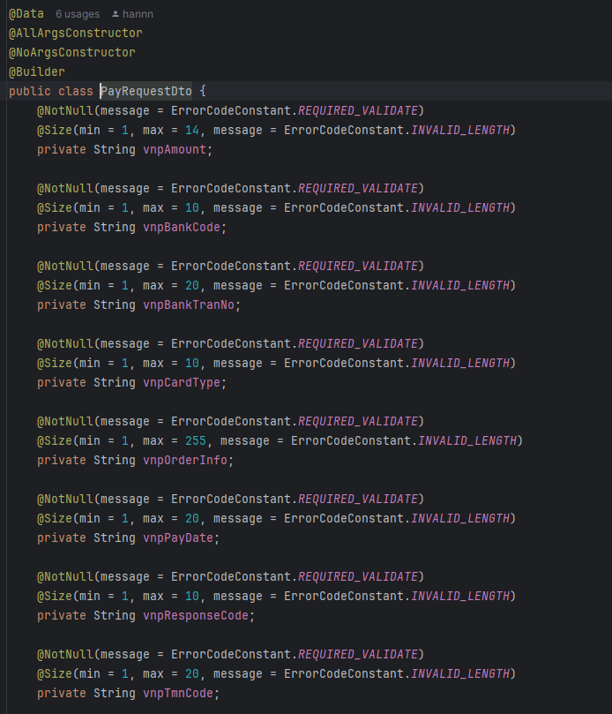 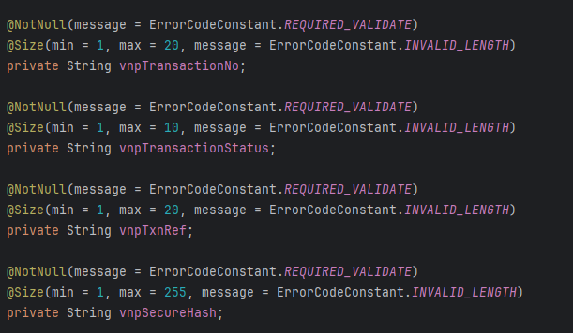

* **Step 7:** Next, we will create a service class to handle the process:
  + Below is the table of status codes returned by VNPAY. Here, we only handle two cases: status code "00" for success, and any status code other than "00" for failure.



* + As described above, we will proceed to update the order status and update the wallet balance.

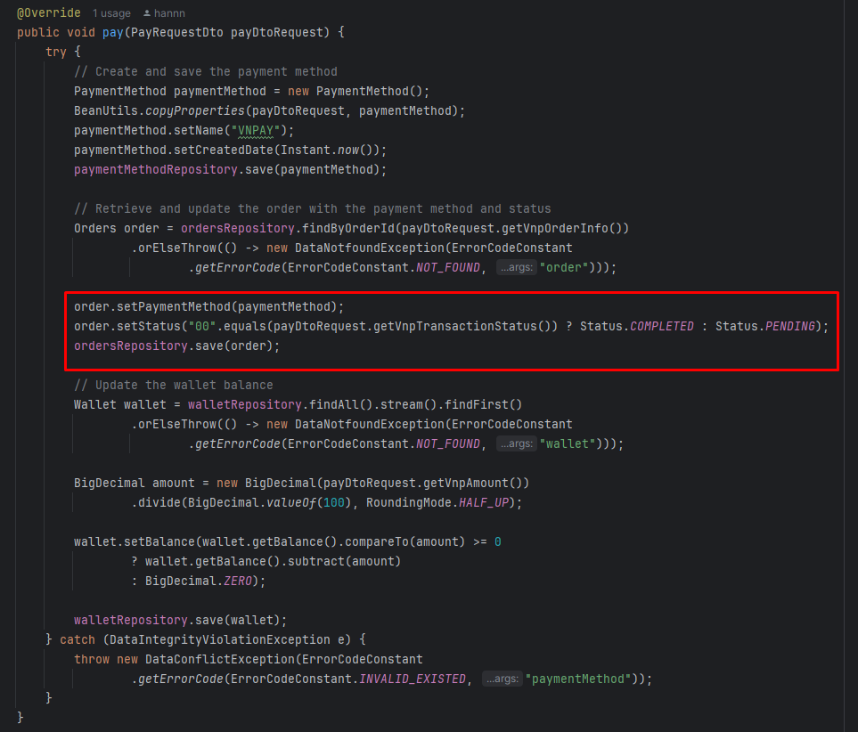

* **Step 8:** Next, we will handle re-checkout:
  + For re-checkout, the order already exists in the database, so we only need to repeat Step 5 to create and return a URL to the client for redirecting to the payment gateway.

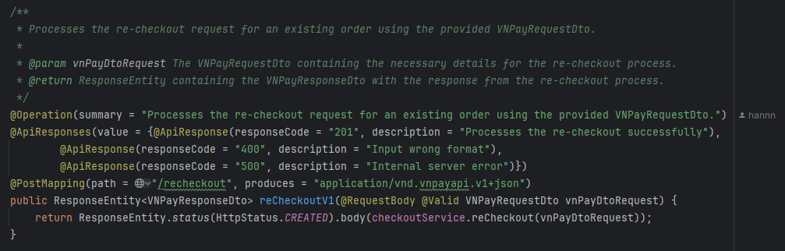

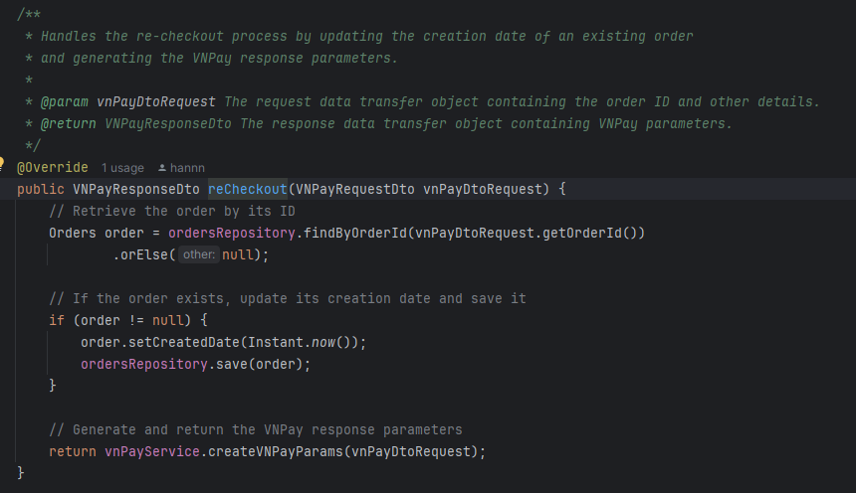

**5.6. Integration on the FE(ReactJS)**

* **Step 1:** Whether the payment is successful or failed, VNPAY will redirect to the URL we have configured, along with parameters containing the transaction status. We just need to extract these and send them to the server for the server to proceed with the steps from Step 6 onwards.

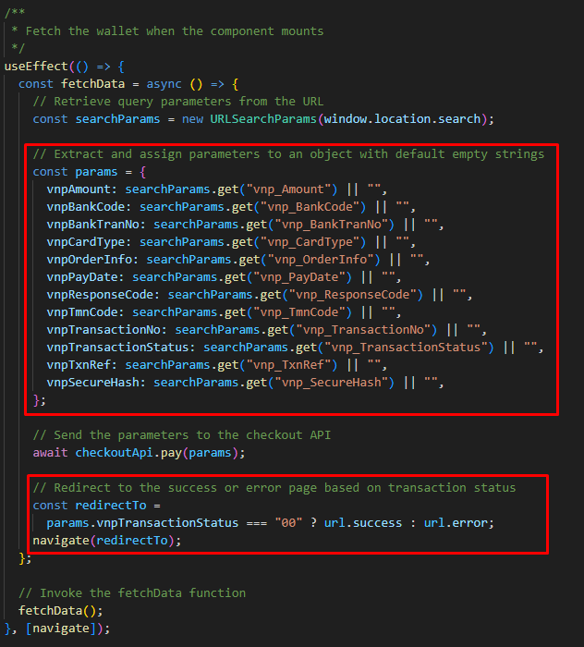

=> And with that, we have successfully integrated the VNPAY payment gateway into our application.

**6. Run source**

**6.1. Run source BE:**

* **Step 1:** Clean Maven
* **Step 2:** Build Maven
* **Step 3:** Run Application on port 8081

**6.2. Run source FE:**

* **Step 1:** npm i
* **Step 2:** npm start

**7. Documentation**

* **Official VNPAY Documentation:** <https://sandbox.vnpayment.vn/apis/docs/thanh-toan-pay/pay.html>
* **Demo Information:** <https://sandbox.vnpayment.vn/apis/vnpay-demo/>
* **API Docs:** <http://localhost:8081/swagger-ui/index.html/>